

JAS WORLDWIDE
GROUP OF COMPANIES

FRANGO
CSV Import File Specification

(Version 0.3)

JAS Worldwide Financial Services Limited
Cargo Point,
Bedfont Road,
Stanwell,
Middlesex,
TW19 7NZ.
Tel: +44 (0)1784 240049.
Fax: +44 (0)1784 266928.
jasww@jasww.com
www.jasww.com
Version Control

Date of Creation | Version Number | Reason for Modification
25 September 2001 | 0.1 | Initial Draft
20 January 2003 | 0.2 | Updated to latest Import Specification used in Frango and addition information on Frango accounts and signage in input forms
20 November 2004 | 0.3 | Update of specification for branch in field 5

Authors: Martin Macaulay
Technical Review:
User Review:

Table of Contents

Introduction 5
Overview 5
Scope and objectives 5
Assumptions 5
Section 1: Explanation of document structure 6
Section 2: Format of file name 6
Section 3: Format of file 6
Section 4 : Data Elements Explanatory Notes 7
Section 5: Data Elements of Frango csv file 8
Section 6: Value format of numerical values 8
Section 7: Sample csv file for Frango 9
Section 8: Appearance in Frango of csv file imported with Specification MM7 16
Form 310Q Fixed Assets 16
Form 320Q Gross Profit by Mode 17
Form 321Q Analysis of JASWW Group Turnover 18
Form 321Q Analysis of JASWW Group Purchases 18
Form 330Q Profit and Loss Account – detail of account 7440 20
Form 330Q Profit and Loss Account – detail of account 8440 20
Form 340Q Reserve Movements 21
Form 350Q Balance Sheet 21
Form 350Q Balance Sheet – detail of account 1240 23
Form 350Q Balance Sheet – detail of account 2240 24
Loan Debtors JAS Worldwide Group - detail of account 1340 25
Loan Creditors JAS Worldwide Group - detail of account 2340 25
Section 9: Other documents for reference 26
0211SGSINac.csv 26
0211SGSINac with notes.xls 26
Frango Excel sheets with CSV sheetV0.10 .xls 26
Section 10: Frango developments to be borne in mind 26
New codes 26
Cashflow reporting 26
Period 13 26
Audit Pack 26
Glossary 27

Introduction

Overview

Scope and objectives

This document has been written to accomplish the following objectives:

- Identify the data elements in an external accounting system required to create a csv file for import to Frango Reporting program using a pre-defined import specification set-up in Frango
- Ensure all accounting systems output the same ASCII files for FRANGO.

The document does not detail how to output the data from the various accounting systems or import data into Frango Accounting program. The document is to be used as a guideline and all the data definitions have been based around the import specification MM7 defined by JASWWFS.

Assumptions

It is assumed that the reader is familiar with the information requirements necessary to complete the Frango input forms, that generate the data submitted to JASWWFS on a monthly basis, using the Frango Reporting Program.

Section 1: Explanation of document structure

This document uses both tables and narratives together with contents of a sample csv and screen prints of how data appears in Frango once imported using import specification in Frango MM7.fzg

Section 2: Format of file name

The file name must take the following format: {period}{company code}ac.csv

Period is defined as yymm. For example 0206 would be Year 2002 month of June.
Company code is code that is used by reporting company using Frango to submit results and is normally the ISO country code followed by the city code.

For example JAS Argentina submitting year to date results at August 2003, the file name would be 0308ARBUEac.csv

Section 3: Format of file

When exporting data from the external accounting system, files must be in format ASCII Oem or ASCII ANSI format, in other words as normal text files. The files can be contain a number of values on the same row, but must be separated by a comma.

Section 4 : Data Elements Explanatory Notes

Account name:
This may be accounting description used locally or that which is defined in Frango Reporting package. This field is only for reference purposes.

Account code:
This code is the Frango account code as defined in Frango account structure

Counter Company:
This code relates to company with which reporting company has had transactions. It only relates to JAS Worldwide Group Companies. Other non JAS group Companies are considered as third party transactions.

Mode:
The type of business operation as defined by Mode in Frango.
The area of business must be classified as one of following:
AI (Air Import),
AE (Air Export),
MI(Maritime Import),
ME (Maritime Export FCL),
CHB (Customs House Brokerage),
NV (Maritime Export NVOCC),
WPT (Warehouse/Packing/Trucking),
PR (Projects),
OTH (Other)

Branch :
This field may be used to split information between branches.

Blank-2 :
For future use

Amount:
This is the amount as exists in local accounting system. It is always the year to date amount. The signage in the extracted file must correspond to the signage corresponding in Frango System. For example a trade creditor will have ‘-‘ , share capital will be ‘+’

Section 5: Data Elements of Frango csv file

Field  number  (1) | Field Name  (2) | Field  Type  (3) | Decimal  Req.  Fixed/  Variable  (4) | Max  Field  Length  (5) | Status  (6) | Specific Data selection  (7)
1 | Account name | Text | V |  | M
2 | Account code | alphanumeric |  | 13 | M | Frango account codes
3 | Counter Company | Text |  | 6 | M
4 | Mode | Text |  | 4 | M | AE,AI,ME,MI,WPT,CHB,OTH
5 | Branch | Text |  | 4 | M | Branch office code eg BUE, VLC
6 | Blank |  |  | 0 | M
7 | Amount | Numeric | Decimal | 18 | M | See value format
Table 1 –data fields for Frango csv file

Table 1 above details the csv data elements.

Column 1, of table 1 shows field reference number

The data elements or fields are those necessary for the file to be successfully imported into FRANGO.
Columns 2 – 7 shows the attributes of each data elements as follows:

Column 2 Field Name-.
Column 3 Field Type (Char, Text or Numeric).
Column 4 Decimal Required (Fixed or Variable) – applicable to numeric fields.
Column 5 Max Field Length – the number of characters/letters/numbers a field can have.
Column 6 Status – specifies whether the data element is mandatory (M), Conditional Mandatory(CM) or optional (O).
Column 7 Specific Data Selection – where field data must meet Frango reporting codes

Section 6: Value format of numerical values

The amounts contain in the file must always be year to date figures and the following format of numerical values is to be used:

Positive Values | Negative Values
10 | -10

IMPORTANT NOTE:
Amounts in thousands must not contain “,” ie 345,679.80 must be output as 345679.80 and be followed by appropriate signage as required by Frango.

The defined specification MM7 rounds decimals automatically to nearest whole number and to round thousands where necessary.
For example, if value is 123456.78 it is rounded to 123457; if value is 123456.28 it is rounded to 123456
Hence, there is no requirement to remove decimals from csv created.

When importing to Frango the import specification with FRANGO at JASWWFS adjusts automatically any amount which are required to be shown in round thousands.

Section 7: Sample csv file for Frango

This sample Frango csv file is based on the specification contained in this document and it is provided only as a guideline.

(NOTE: This file does not include a branch code. Full details available from JASWWFS)

The CSV file will be imported to Frango Reporting program using import specification MM7.

The file name of this example 0211SGSINac.csv

Headcount,HCOUNT,ICTOTA,,,, 00000000036.00+
Number of House Bills,SHOUSES,ICTOTA,AE,,, 00000000951.00+
Number of House Bills,SHOUSES,ICTOTA,AI,,, 00000003225.00+
Number of House Bills,SHOUSES,ICTOTA,ME,,, 00000000000.00+
Number of House Bills,SHOUSES,ICTOTA,MI,,, 00000002498.00+
Number of House Bills,SHOUSES,ICTOTA,NV,,, 00000000889.00+
Number of House Bills,SHOUSES,ICTOTA,OTH,,, 00000000000.00+
Number of House Bills,SHOUSES,ICTOTA,PR,,, 00000000000.00+
Number of Master Bills,SMASTERS,ICTOTA,AE,,, 00000000648.00+
Number of Master Bills,SMASTERS,ICTOTA,AI,,, 00000000411.00+
Number of Master Bills,SMASTERS,ICTOTA,ME,,, 00000000000.00+
Number of Master Bills,SMASTERS,ICTOTA,MI,,, 00000000402.00+
Number of Master Bills,SMASTERS,ICTOTA,NV,,, 00000000375.00+
Number of Master Bills,SMASTERS,ICTOTA,OTH,,, 00000000000.00+
Number of Master Bills,SMASTERS,ICTOTA,PR,,, 00000000000.00+
TOTAL INVOICED,TI,ICTOTA,,,, 00014313723.86+
Cash at bank & in hand,1100,,,,, 00001511920.25+
Trade Debtors,1210,,,,, 00002078793.76+
Trade debtors - JAS Worldwide Group,1240,AEDXB,,,, 00000006393.85+
Trade debtors - JAS Worldwide Group,1240,AUSYD,,,, 00000014392.83+
Trade debtors - JAS Worldwide Group,1240,BRSAO,,,, 00000006538.30+
Trade debtors - JAS Worldwide Group,1240,CNSHA,,,, 00000008175.54+
Trade debtors - JAS Worldwide Group,1240,DEFRA,,,, 00000005546.73+
Trade debtors - JAS Worldwide Group,1240,ESBCN,,,, 00000000109.24+
Trade debtors - JAS Worldwide Group,1240,FRPAR,,,, 00000000278.93+
Trade debtors - JAS Worldwide Group,1240,GBLON,,,, 00000000699.24-
Trade debtors - JAS Worldwide Group,1240,HKCHN,,,, 00000002708.87+
Trade debtors - JAS Worldwide Group,1240,HKHKG,,,, 00000007013.16+
Trade debtors - JAS Worldwide Group,1240,ITMIL,,,, 00000054455.90+
Trade debtors - JAS Worldwide Group,1240,JPTYO,,,, 00000019547.90+
Trade debtors - JAS Worldwide Group,1240,KRSEL,,,, 00000002824.32+
Trade debtors - JAS Worldwide Group,1240,MXGDL,,,, 00000032854.49+
Trade debtors - JAS Worldwide Group,1240,MYKUL,,,, 00000004838.83+
Trade debtors - JAS Worldwide Group,1240,NLAMS,,,, 00000000165.16-
Trade debtors - JAS Worldwide Group,1240,NZAKL,,,, 00000011736.68+
Trade debtors - JAS Worldwide Group,1240,PYASU,,,, 00000000650.79+
Trade debtors - JAS Worldwide Group,1240,THBKK,,,, 00000000091.15+
Trade debtors - JAS Worldwide Group,1240,TWTPE,,,, 00000006235.22+
Trade debtors - JAS Worldwide Group,1240,USCOR,,,, 00000032585.93+
Trade debtors - JAS Worldwide Group,1240,ZAJNB,,,, 00000007904.49+
Other Debtors,1290,,,,, 00000011012.51+
Deposits and prepayments,1310,,,,, 00000058543.20+
"Fixed Assets, Furnit / Opening balance",1711OB,,,,, 00000088889.20+
Accum. Depn. Furnitur / Current Year Depn.,1712CYD,,,,, 00000024691.40+
Accum. Depn. Furnitur / Opening Balance,1712OB,,,,, 00000012345.70+
"Fixed Assets, Office / Additions",1721ADD,,,,, 00000005114.00+
"Fixed Assets, Office / Disposals",1721DIS,,,,, 00000004500.00-
"Fixed Assets, Office / Opening balance",1721OB,,,,, 00000286897.56+
Accum. Depn. Office E / Current Year Depn.,1722CYD,,,,, 00000049715.45+
Accum. Depn. Office E/ Disposals,1722DIS,,,,, 00000004500.00-
Accum. Depn. Office / Opening Balance,1722OB,,,,, 00000157820.65+
"Fixed Assets, Vehicl / Opening balance",1751OB,,,,, 00000231517.72+
Accum. Depn. Vehicl / Current Year Depn.,1752CYD,,,,, 00000019293.40+
Accum. Depn. Vehicl / Opening Balance,1752OB,,,,, 00000212224.32+
Other Fixed Assets / Opening balance,1791OB,,,,, 00000080960.00+
Accum. Depn. Other Fixed Ass / Current Year Depn,1792CYD,,,,, 00000010583.30+
Accum. Depn. Other Fixed Ass / Opening Balance,1792OB,,,,, 00000065832.10+
"Overdrafts/short term bank finance,HP & leases",2100,,,,, 00000010077.18-
Trade Creditors,2210,,,,, 00000757476.43-
Trade creditors - JAS Worldwide Group,2240,AUCOR,,,, 00000000205.46-
Trade creditors - JAS Worldwide Group,2240,AEDXB,,,, 00000000051.24+
Trade creditors - JAS Worldwide Group,2240,AUSYD,,,, 00000002493.09-
Trade creditors - JAS Worldwide Group,2240,BRSAO,,,, 00000002338.05-
Trade creditors - JAS Worldwide Group,2240,CHJAS,,,, 00000001030.46-
Trade creditors - JAS Worldwide Group,2240,CHSVC,,,, 00000060420.00-
Trade creditors - JAS Worldwide Group,2240,CNSHA,,,, 00000010463.79-
Trade creditors - JAS Worldwide Group,2240,DEFRA,,,, 00000032211.45-
Trade creditors - JAS Worldwide Group,2240,DKCOR,,,, 00000005217.48-
Trade creditors - JAS Worldwide Group,2240,ESBCN,,,, 00000004697.45-
Trade creditors - JAS Worldwide Group,2240,FRPAR,,,, 00000014522.70-
Trade creditors - JAS Worldwide Group,2240,GBLON,,,, 00000056009.93-
Trade creditors - JAS Worldwide Group,2240,HKCHN,,,, 00000004428.84-
Trade creditors - JAS Worldwide Group,2240,HKHKG,,,, 00000043409.89-
Trade creditors - JAS Worldwide Group,2240,HUBUD,,,, 00000001269.07-
Trade creditors - JAS Worldwide Group,2240,ITMIL,,,, 00000210103.01-
Trade creditors - JAS Worldwide Group,2240,JASWW,,,, 00000003779.25-
Trade creditors - JAS Worldwide Group,2240,JPTYO,,,, 00000000662.33-
Trade creditors - JAS Worldwide Group,2240,KRSEL,,,, 00000002219.01-
Trade creditors - JAS Worldwide Group,2240,MXGDL,,,, 00000039468.15-
Trade creditors - JAS Worldwide Group,2240,MYKUL,,,, 00000000392.92-
Trade creditors - JAS Worldwide Group,2240,NLAMS,,,, 00000002158.39-
Trade creditors - JAS Worldwide Group,2240,NZAKL,,,, 00000001626.81-
Trade creditors - JAS Worldwide Group,2240,PELIM,,,, 00000002167.18-
Trade creditors - JAS Worldwide Group,2240,THBKK,,,, 00000001324.50-
Trade creditors - JAS Worldwide Group,2240,TWTPE,,,, 00000006568.28-
Trade creditors - JAS Worldwide Group,2240,USCOR,,,, 00000006692.80-
Trade creditors - JAS Worldwide Group,2240,ZAJNB,,,, 00000004809.30-
Other creditors,2290,,,,, 00000092996.13-
Accruals - traffic - 3rd party,2410,,,,, 00000330387.14-
Accruals - traffic - JAS Worldwide Group,2440,AUMEL,,,, 00000000070.80-
Accruals - traffic - JAS Worldwide Group,2440,BRSAO,,,, 00000005217.25-
Accruals - traffic - JAS Worldwide Group,2440,CHJAS,,,, 00000000604.05-
Accruals - traffic - JAS Worldwide Group,2440,CNSHA,,,, 00000002309.22-
Accruals - traffic - JAS Worldwide Group,2440,DEFRA,,,, 00000001876.75-
Accruals - traffic - JAS Worldwide Group,2440,DKCOR,,,, 00000003132.00-
Accruals - traffic - JAS Worldwide Group,2440,ESBCN,,,, 00000000383.95-
Accruals - traffic - JAS Worldwide Group,2440,FRPAR,,,, 00000001412.53-
Accruals - traffic - JAS Worldwide Group,2440,GBLON,,,, 00000004189.35-
Accruals - traffic - JAS Worldwide Group,2440,HKCHN,,,, 00000000143.20-
Accruals - traffic - JAS Worldwide Group,2440,HKHKG,,,, 00000001944.60-
Accruals - traffic - JAS Worldwide Group,2440,ITMIL,,,, 00000031727.00-
Accruals - traffic - JAS Worldwide Group,2440,MXGDL,,,, 00000000500.83-
Accruals - traffic - JAS Worldwide Group,2440,MYKUL,,,, 00000000890.99-
Accruals - traffic - JAS Worldwide Group,2440,THBKK,,,, 00000001235.53-
Accruals - traffic - JAS Worldwide Group,2440,TWTPE,,,, 00000001896.66-
Accruals - traffic - JAS Worldwide Group,2440,USCOR,,,, 00000008685.37-
Accruals - traffic - JAS Worldwide Group,2440,UYMVD,,,, 00000000998.25-
Accruals - non traffic (overheads),2510,,,,, 00000302306.50-
"Accruals - taxes (inc corporation, payroll & oth",2550,,,,, 00000070557.77-
Bad/Doubtful debt provision,2610,,,,, 00000283216.54-
"Long term bank finance, HP & Finance leases",2700,,,,, 00000049369.15-
Share Capital / Opening balance,2910OB,,,,, 00001000000.00+
Profit & Loss reserv / Opening balance,2950OB,,,,, 00000341405.62+
Turnover - 3rd party,3010,,AE,,, 00003940328.99+
Turnover - 3rd party,3010,,AI,,, 00002003711.60+
Turnover - 3rd party,3010,,NV,,, 00001655241.85+
Turnover - 3rd party,3010,,MI,,, 00002808035.63+
Turnover - 3rd party,3010,,OTH,,, 00000009489.91+
Turnover - JASWW,3040,AEDXB,AE,,, 00000018118.63+
Turnover - JASWW,3040,AEDXB,NV,,, 00000001284.01+
Turnover - JASWW,3040,ARBUE,NV,,, 00000022755.34+
Turnover - JAS Worldwide Group Intercompany,I3040,AEDXB,,,, 00000019402.64+
Turnover - JASWW,3040,AUSYD,AE,,, 00000106309.55+
Turnover - JAS Worldwide Group Intercompany,I3040,ARBUE,,,, 00000022755.34+
Turnover - JASWW,3040,AUSYD,AI,,, 00000021135.40+
Turnover - JASWW,3040,AUSYD,NV,,, 00000018896.06+
Turnover - JASWW,3040,AUSYD,MI,,, 00000002453.49+
Turnover - JASWW,3040,AUSYD,OTH,,, 00000001185.48+
Turnover - JASWW,3040,BRSAO,AE,,, 00000302040.22+
Turnover - JAS Worldwide Group Intercompany,I3040,AUSYD,,,, 00000149979.98+
Turnover - JASWW,3040,BRSAO,NV,,, 00000055354.25+
Turnover - JASWW,3040,BRSAO,MI,,, 00000009727.70+
Turnover - JASWW,3040,BRSAO,OTH,,, 00000001456.22+
Turnover - JASWW,3040,CNSHA,AE,,, 00000011022.79+
Turnover - JAS Worldwide Group Intercompany,I3040,BRSAO,,,, 00000368578.39+
Turnover - JASWW,3040,CNSHA,NV,,, 00000028402.30+
Turnover - JASWW,3040,CNSHA,MI,,, 00000000624.60+
Turnover - JASWW,3040,DEFRA,AE,,, 00000010924.95+
Turnover - JAS Worldwide Group Intercompany,I3040,CNSHA,,,, 00000040049.69+
Turnover - JASWW,3040,DEFRA,AI,,, 00000001577.52+
Turnover - JASWW,3040,DEFRA,NV,,, 00000008765.49+
Turnover - JASWW,3040,DEFRA,OTH,,, 00000000161.10+
Turnover - JASWW,3040,DKCOR,NV,,, 00000002196.00+
Turnover - JAS Worldwide Group Intercompany,I3040,DEFRA,,,, 00000021429.06+
Turnover - JASWW,3040,DKCOR,MI,,, 00000000192.00+
Turnover - JASWW,3040,ESBCN,MI,,, 00000000922.20+
Turnover - JAS Worldwide Group Intercompany,I3040,DKCOR,,,, 00000002388.00+
Turnover - JASWW,3040,ESBCN,OTH,,, 00000000126.74+
Turnover - JASWW,3040,FRPAR,AE,,, 00000024710.68+
Turnover - JAS Worldwide Group Intercompany,I3040,ESBCN,,,, 00000001048.94+
Turnover - JASWW,3040,FRPAR,AI,,, 00000000140.00+
Turnover - JASWW,3040,FRPAR,NV,,, 00000001741.99-
Turnover - JASWW,3040,FRPAR,OTH,,, 00000001241.08+
Turnover - JASWW,3040,GBLON,AE,,, 00000060093.02+
Turnover - JAS Worldwide Group Intercompany,I3040,FRPAR,,,, 00000024349.77+
Turnover - JASWW,3040,GBLON,AI,,, 00000001378.70+
Turnover - JASWW,3040,GBLON,NV,,, 00000002522.39-
Turnover - JASWW,3040,GBLON,OTH,,, 00000018573.06+
Turnover - JASWW,3040,HKCHN,AE,,, 00000002068.41+
Turnover - JAS Worldwide Group Intercompany,I3040,GBLON,,,, 00000077522.39+
Turnover - JASWW,3040,HKCHN,NV,,, 00000003851.97+
Turnover - JASWW,3040,HKHKG,AE,,, 00000201614.54+
Turnover - JAS Worldwide Group Intercompany,I3040,HKCHN,,,, 00000005920.38+
Turnover - JASWW,3040,HKHKG,AI,,, 00000002197.62-
Turnover - JASWW,3040,HKHKG,NV,,, 00000041345.95+
Turnover - JASWW,3040,HKHKG,MI,,, 00000011139.04+
Turnover - JASWW,3040,HKHKG,OTH,,, 00000005507.15+
Turnover - JASWW,3040,HUBUD,AE,,, 00000000462.82+
Turnover - JAS Worldwide Group Intercompany,I3040,HKHKG,,,, 00000257409.06+
Turnover - JASWW,3040,ITMIL,AE,,, 00000235864.93+
Turnover - JAS Worldwide Group Intercompany,I3040,HUBUD,,,, 00000000462.82+
Turnover - JASWW,3040,ITMIL,AI,,, 00000137209.48+
Turnover - JASWW,3040,ITMIL,NV,,, 00000129490.06+
Turnover - JASWW,3040,ITMIL,MI,,, 00000011020.34+
Turnover - JASWW,3040,ITMIL,OTH,,, 00000036215.90+
Turnover - JASWW,3040,JPTYO,AE,,, 00000073854.20+
Turnover - JAS Worldwide Group Intercompany,I3040,ITMIL,,,, 00000549800.71+
Turnover - JASWW,3040,JPTYO,AI,,, 00000001742.60+
Turnover - JASWW,3040,JPTYO,NV,,, 00000004417.68+
Turnover - JASWW,3040,JPTYO,MI,,, 00000000037.11-
Turnover - JASWW,3040,JPTYO,OTH,,, 00000000937.62+
Turnover - JASWW,3040,KRSEL,AE,,, 00000031958.66+
Turnover - JAS Worldwide Group Intercompany,I3040,JPTYO,,,, 00000080914.99+
Turnover - JASWW,3040,KRSEL,AI,,, 00000001938.30+
Turnover - JASWW,3040,KRSEL,NV,,, 00000004256.77+
Turnover - JASWW,3040,KRSEL,OTH,,, 00000000034.80+
Turnover - JASWW,3040,MXGDL,AE,,, 00000301705.21+
Turnover - JAS Worldwide Group Intercompany,I3040,KRSEL,,,, 00000038188.53+
Turnover - JASWW,3040,MXGDL,NV,,, 00000330880.65+
Turnover - JASWW,3040,MYKUL,AE,,, 00000009886.51+
Turnover - JAS Worldwide Group Intercompany,I3040,MXGDL,,,, 00000632585.86+
Turnover - JASWW,3040,MYKUL,AI,,, 00000000246.50+
Turnover - JASWW,3040,MYKUL,NV,,, 00000000385.35+
Turnover - JASWW,3040,NLAMS,AE,,, 00000000116.49-
Turnover - JAS Worldwide Group Intercompany,I3040,MYKUL,,,, 00000010518.36+
Turnover - JASWW,3040,NLAMS,AI,,, 00000000301.70+
Turnover - JASWW,3040,NLAMS,NV,,, 00000000903.77-
Turnover - JASWW,3040,NLAMS,OTH,,, 00000000026.10-
Turnover - JASWW,3040,NZAKL,AE,,, 00000021090.18+
Turnover - JAS Worldwide Group Intercompany,I3040,NLAMS,,,, 00000000744.66-
Turnover - JASWW,3040,NZAKL,AI,,, 00000000443.20+
Turnover - JASWW,3040,NZAKL,NV,,, 00000010110.38+
Turnover - JASWW,3040,NZAKL,MI,,, 00000000316.80+
Turnover - JASWW,3040,NZAKL,OTH,,, 00000002296.35+
Turnover - JASWW,3040,PYASU,AE,,, 00000000650.79+
Turnover - JAS Worldwide Group Intercompany,I3040,NZAKL,,,, 00000034256.91+
Turnover - JASWW,3040,THBKK,AE,,, 00000008137.49+
Turnover - JAS Worldwide Group Intercompany,I3040,PYASU,,,, 00000000650.79+
Turnover - JASWW,3040,THBKK,AI,,, 00000000351.70+
Turnover - JASWW,3040,THBKK,NV,,, 00000005499.21+
Turnover - JASWW,3040,TWTPE,AE,,, 00000069289.27+
Turnover - JAS Worldwide Group Intercompany,I3040,THBKK,,,, 00000013988.40+
Turnover - JASWW,3040,TWTPE,AI,,, 00000000958.65+
Turnover - JASWW,3040,TWTPE,NV,,, 00000015471.28+
Turnover - JASWW,3040,TWTPE,OTH,,, 00000017137.23+
Turnover - JASWW,3040,USCOR,AE,,, 00000049820.21+
Turnover - JAS Worldwide Group Intercompany,I3040,TWTPE,,,, 00000102856.43+
Turnover - JASWW,3040,USCOR,AI,,, 00000002602.21+
Turnover - JASWW,3040,USCOR,NV,,, 00000081277.55+
Turnover - JASWW,3040,USCOR,MI,,, 00000006415.45+
Turnover - JASWW,3040,USCOR,OTH,,, 00000039325.49+
Turnover - JASWW,3040,ZAJNB,AE,,, 00000007629.24+
Turnover - JAS Worldwide Group Intercompany,I3040,USCOR,,,, 00000179440.91+
Turnover - JASWW,3040,ZAJNB,AI,,, 00000000140.00+
Turnover - JASWW,3040,ZAJNB,NV,,, 00000009958.30+
Turnover - JASWW,3040,ZAJNB,MI,,, 00000001616.95+
Turnover - JASWW,3040,ZAJNB,OTH,,, 00000005680.07+
Purchases - 3rd party,4010,,AE,,, 00004495026.69+
Purchases - 3rd party,4010,,AI,,, 00000202244.70+
Purchases - 3rd party,4010,,NV,,, 00001618935.08+
Purchases - 3rd party,4010,,MI,,, 00000707064.44+
Purchases - 3rd party,4010,,OTH,,, 00000134891.93+
Purchases - JASWW,4040,AEDXB,AI,,, 00000000025.62-
Turnover - JAS Worldwide Group Intercompany,I3040,ZAJNB,,,, 00000025024.56+
Purchases - JASWW,4040,AUSYD,AE,,, 00000000392.30+
Purchases - JAS Worldwide Group Intercompany,I4040,AEDXB,,,, 00000000025.62-
Purchases - JASWW,4040,AUSYD,AI,,, 00000014456.63+
Purchases - JASWW,4040,AUSYD,NV,,, 00000002385.55+
Purchases - JASWW,4040,AUSYD,MI,,, 00000014139.28+
Purchases - JASWW,4040,AUSYD,OTH,,, 00000000239.97-
Purchases - JASWW,4040,BRSAO,AI,,, 00000003804.80+
Purchases - JAS Worldwide Group Intercompany,I4040,AUSYD,,,, 00000031133.79+
Purchases - JASWW,4040,CHJAS,AE,,, 00000000628.70+
Purchases - JAS Worldwide Group Intercompany,I4040,BRSAO,,,, 00000003804.80+
Purchases - JASWW,4040,CHJAS,AI,,, 00000009675.79+
Purchases - JASWW,4040,CHJAS,MI,,, 00000004892.62+
Purchases - JASWW,4040,CNSHA,AE,,, 00000016705.28+
Purchases - JAS Worldwide Group Intercompany,I4040,CHJAS,,,, 00000015197.11+
Purchases - JASWW,4040,CNSHA,AI,,, 00000020924.18+
Purchases - JASWW,4040,CNSHA,NV,,, 00000000548.49+
Purchases - JASWW,4040,CNSHA,MI,,, 00000010022.42+
Purchases - JASWW,4040,DEFRA,AE,,, 00000023017.69+
Purchases - JAS Worldwide Group Intercompany,I4040,CNSHA,,,, 00000048200.37+
Purchases - JASWW,4040,DEFRA,AI,,, 00000034926.95+
Purchases - JASWW,4040,DEFRA,NV,,, 00000041283.29+
Purchases - JASWW,4040,DEFRA,MI,,, 00000083075.65+
Purchases - JASWW,4040,DKCOR,AI,,, 00000005078.20+
Purchases - JAS Worldwide Group Intercompany,I4040,DEFRA,,,, 00000182303.58+
Purchases - JASWW,4040,DKCOR,NV,,, 00000000868.32+
Purchases - JASWW,4040,DKCOR,MI,,, 00000007862.93+
Purchases - JASWW,4040,ESBCN,AE,,, 00000000548.58+
Purchases - JAS Worldwide Group Intercompany,I4040,DKCOR,,,, 00000013809.45+
Purchases - JASWW,4040,ESBCN,AI,,, 00000028216.60+
Purchases - JASWW,4040,ESBCN,NV,,, 00000000168.04+
Purchases - JASWW,4040,ESBCN,MI,,, 00000037694.17+
Purchases - JASWW,4040,FRPAR,AE,,, 00000006198.64+
Purchases - JAS Worldwide Group Intercompany,I4040,ESBCN,,,, 00000066627.39+
Purchases - JASWW,4040,FRPAR,AI,,, 00000022515.80+
Purchases - JASWW,4040,FRPAR,NV,,, 00000025532.88+
Purchases - JASWW,4040,FRPAR,MI,,, 00000033074.53+
Purchases - JASWW,4040,FRPAR,OTH,,, 00000000184.00-
Purchases - JASWW,4040,GBLON,AE,,, 00000041821.04+
Purchases - JAS Worldwide Group Intercompany,I4040,FRPAR,,,, 00000087137.85+
Purchases - JASWW,4040,GBLON,AI,,, 00000185042.51+
Purchases - JASWW,4040,GBLON,NV,,, 00000030542.14+
Purchases - JASWW,4040,GBLON,MI,,, 00000078656.83+
Purchases - JASWW,4040,HKCHN,AE,,, 00000000470.65+
Purchases - JAS Worldwide Group Intercompany,I4040,GBLON,,,, 00000336062.52+
Purchases - JASWW,4040,HKCHN,AI,,, 00000010699.12+
Purchases - JASWW,4040,HKCHN,NV,,, 00000001355.64+
Purchases - JASWW,4040,HKCHN,MI,,, 00000000790.02+
Purchases - JASWW,4040,HKHKG,AE,,, 00000022312.47+
Purchases - JAS Worldwide Group Intercompany,I4040,HKCHN,,,, 00000013315.43+
Purchases - JASWW,4040,HKHKG,AI,,, 00000098531.62+
Purchases - JASWW,4040,HKHKG,NV,,, 00000017986.89+
Purchases - JASWW,4040,HKHKG,MI,,, 00000075039.85+
Purchases - JASWW,4040,HKHKG,OTH,,, 00000003281.20+
Purchases - JASWW,4040,HUBUD,AI,,, 00000001251.12+
Purchases - JAS Worldwide Group Intercompany,I4040,HKHKG,,,, 00000217152.03+
Purchases - JASWW,4040,ITMIL,AE,,, 00000063888.25+
Purchases - JAS Worldwide Group Intercompany,I4040,HUBUD,,,, 00000001251.12+
Purchases - JASWW,4040,ITMIL,AI,,, 00000783491.95+
Purchases - JASWW,4040,ITMIL,NV,,, 00000192406.38+
Purchases - JASWW,4040,ITMIL,MI,,, 00001081900.37+
Purchases - JASWW,4040,ITMIL,OTH,,, 00000002874.30+
Purchases - JASWW,4040,JPTYO,AE,,, 00000000224.50+
Purchases - JAS Worldwide Group Intercompany,I4040,ITMIL,,,, 00002124561.25+
Purchases - JASWW,4040,JPTYO,AI,,, 00000022452.43+
Purchases - JASWW,4040,JPTYO,NV,,, 00000003174.86+
Purchases - JASWW,4040,JPTYO,MI,,, 00000001242.58+
Purchases - JASWW,4040,JPTYO,OTH,,, 00000000008.58-
Purchases - JASWW,4040,KRSEL,AI,,, 00000009351.53+
Purchases - JAS Worldwide Group Intercompany,I4040,JPTYO,,,, 00000027085.79+
Purchases - JASWW,4040,KRSEL,NV,,, 00000000070.70-
Purchases - JASWW,4040,KRSEL,MI,,, 00000006852.47+
Purchases - JASWW,4040,MXGDL,AI,,, 00000002367.89-
Purchases - JAS Worldwide Group Intercompany,I4040,KRSEL,,,, 00000016133.30+
Purchases - JASWW,4040,MXGDL,MI,,, 00000040318.64+
Purchases - JASWW,4040,MYKUL,NV,,, 00000001353.53+
Purchases - JAS Worldwide Group Intercompany,I4040,MXGDL,,,, 00000037950.75+
Purchases - JASWW,4040,MYKUL,OTH,,, 00000000392.92+
Purchases - JASWW,4040,NLAMS,AE,,, 00000004420.25+
Purchases - JAS Worldwide Group Intercompany,I4040,MYKUL,,,, 00000001746.45+
Purchases - JASWW,4040,NLAMS,AI,,, 00000029034.54+
Purchases - JASWW,4040,NLAMS,MI,,, 00000004169.35+
Purchases - JASWW,4040,NZAKL,AE,,, 00000000026.99-
Purchases - JAS Worldwide Group Intercompany,I4040,NLAMS,,,, 00000037624.14+
Purchases - JASWW,4040,NZAKL,AI,,, 00000003623.78+
Purchases - JASWW,4040,NZAKL,MI,,, 00000002372.64+
Purchases - JASWW,4040,PELIM,AI,,, 00000002167.18+
Purchases - JAS Worldwide Group Intercompany,I4040,NZAKL,,,, 00000005969.43+
Purchases - JASWW,4040,THBKK,AE,,, 00000000314.43+
Purchases - JAS Worldwide Group Intercompany,I4040,PELIM,,,, 00000002167.18+
Purchases - JASWW,4040,THBKK,AI,,, 00000005610.27+
Purchases - JASWW,4040,THBKK,NV,,, 00000018346.80+
Purchases - JASWW,4040,THBKK,MI,,, 00000009134.10+
Purchases - JASWW,4040,TWTPE,AE,,, 00000002551.70+
Purchases - JAS Worldwide Group Intercompany,I4040,THBKK,,,, 00000033405.60+
Purchases - JASWW,4040,TWTPE,AI,,, 00000012408.67+
Purchases - JASWW,4040,TWTPE,MI,,, 00000002993.90+
Purchases - JASWW,4040,TWTPE,OTH,,, 00000000115.22-
Purchases - JASWW,4040,USCOR,AE,,, 00000140775.34+
Purchases - JAS Worldwide Group Intercompany,I4040,TWTPE,,,, 00000017839.05+
Purchases - JASWW,4040,USCOR,AI,,, 00000067891.17+
Purchases - JASWW,4040,USCOR,NV,,, 00000005445.65+
Purchases - JASWW,4040,USCOR,MI,,, 00000142148.23+
Purchases - JASWW,4040,USCOR,OTH,,, 00000001544.03+
Purchases - JASWW,4040,UYMVD,AI,,, 00000000371.85+
Purchases - JAS Worldwide Group Intercompany,I4040,USCOR,,,, 00000357804.42+
Purchases - JASWW,4040,ZAJNB,AI,,, 00000000116.85+
Purchases - JAS Worldwide Group Intercompany,I4040,UYMVD,,,, 00000000371.85+
Purchases - JASWW,4040,ZAJNB,MI,,, 00000004809.30+
Staff Costs,5000,,,,, 00001274779.02+
Property/utilities/office supplies,6100,,,,, 00000238635.10+
Communications,6200,,,,, 00000059346.08+
Travel & transportation,6300,,,,, 00000068283.77+
Marketing,6400,,,,, 00000024020.96+
Other overhead costs,6900,,,,, 00000114100.04+
External professional fees,7110,,,,, 00000021054.40+
Management charges - JASWW,7440,CHSVC,,,, 00000055820.00+
Management charges - JASWW,7440,JASWW,,,, 00000024891.94+
Foreign exchange - realized,8250,,,,, 00000095732.36-
Interest income - 3rd party,8310,,,,, 00000001336.91+
Interest expense - 3rd party,8410,,,,, 00000004111.71+
Interest expense - JASWW,8440,CHSVC,,,, 00000004600.00+
Interest expense - JASWW,8440,JASWW,,,, 00000000766.17+
Bad/doubtful debts provision,8510,,,,, 00000071991.11+
"Depreciation - Furniture, Fixtures & Fittings",8712,,,,, 00000024691.40+
Depreciation - Office Equipment & Computers,8722,,,,, 00000049715.45+
Depreciation - Vehicle & Transportation Equipment,8752,,,,, 00000019293.40+
Depreciation - Other fixed assets,8792,,,,, 00000010583.30+
Tax Charge,9500,,,,, 00000064742.14+
Purchases - JAS Worldwide Group Intercompany,I4040,ZAJNB,,,, 00000004926.15+

Section 8: Appearance in Frango of csv file imported with Specification MM7

As at 20/1/03 , the forms used to enter data manually in Frango, which would be filled when a csv file is imported are:

310Q Fixed Assets
320Q Gross Profit by Mode
321Q Analysis of JASWW Group Turnover
322Q Analysis of JASWW Group Purchases
330Q Profit and Loss
340Q Reserve Movements Year to Date
350Q Balance Sheet
and
INTF which provides the means to produce certain summary reports from data loaded in Frango , and is only necessary for to import data from csv file.

When the example file 0211SGSINac.csv in this document is imported the data would appear in the above input forms as seen in following screen prints.

Form 310Q Fixed Assets

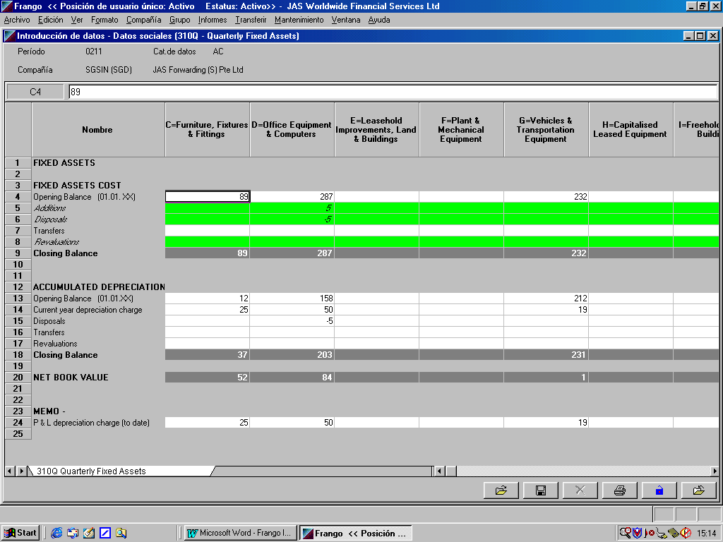

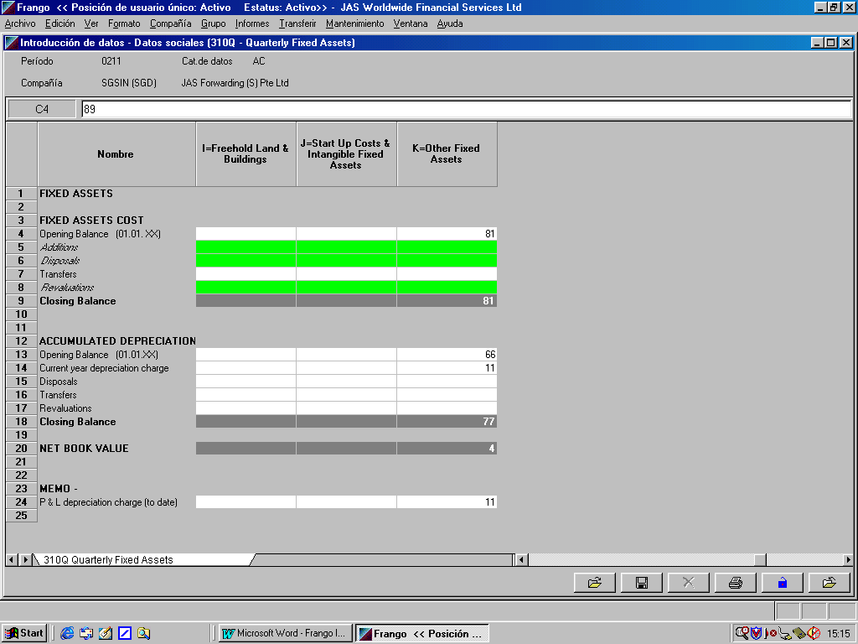
Form 310Q (extract ctd)

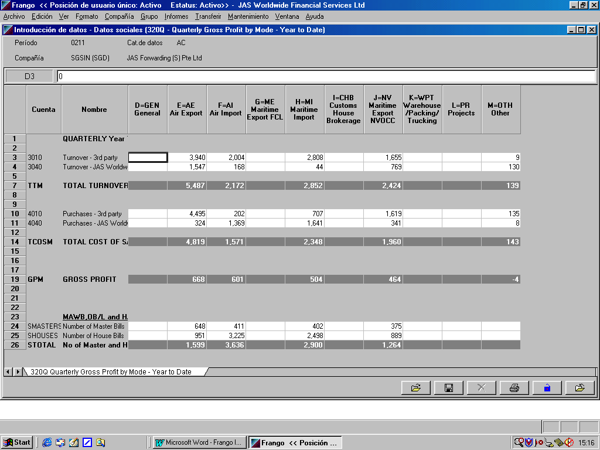
Form 320Q Gross Profit by Mode

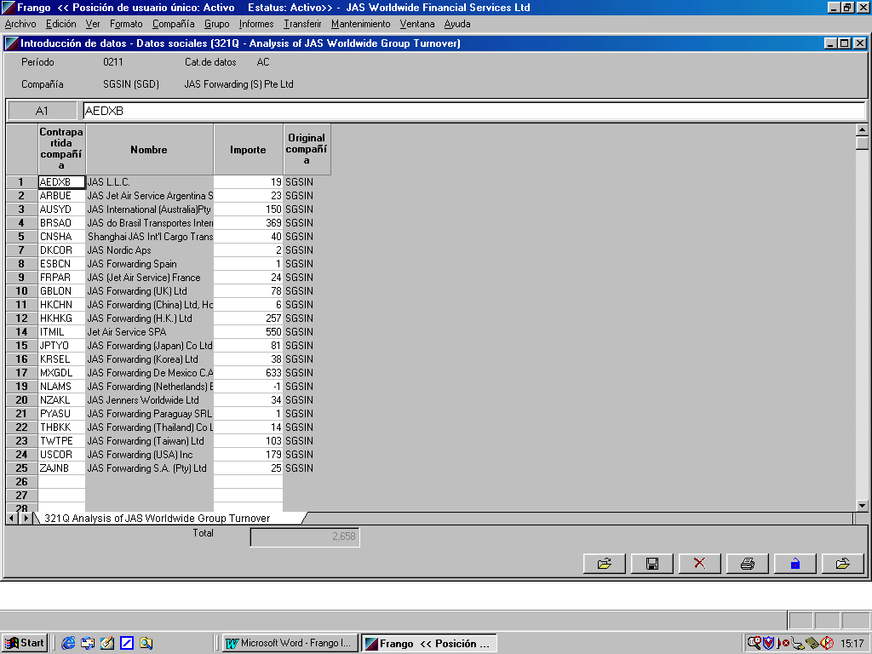
Form 321Q Analysis of JASWW Group Turnover

Form 321Q Analysis of JASWW Group Purchases
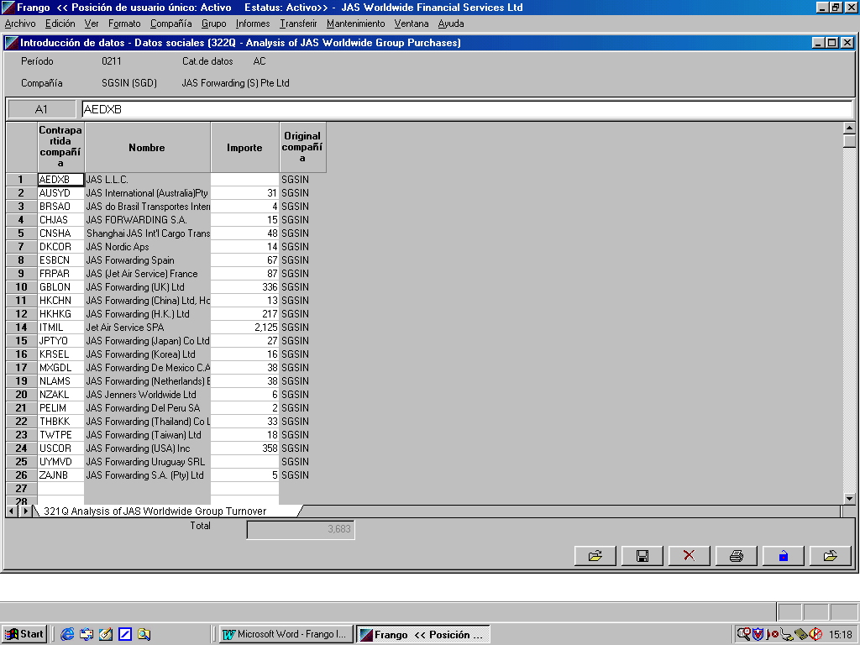

Form 330Q Profit and Loss Account
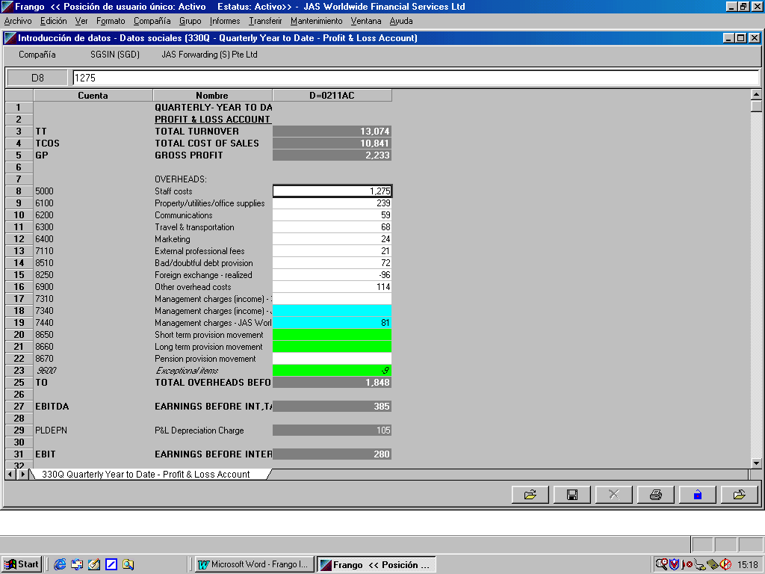
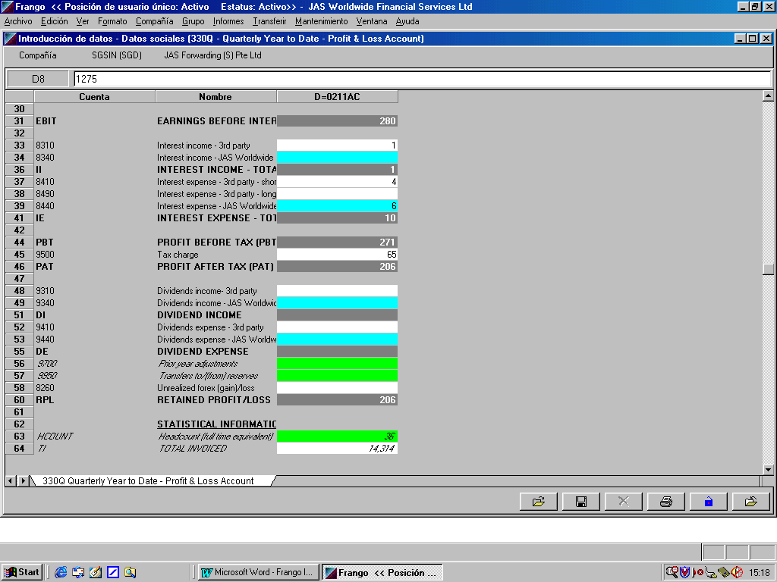

Form 330Q Profit and Loss Account – detail of account 7440
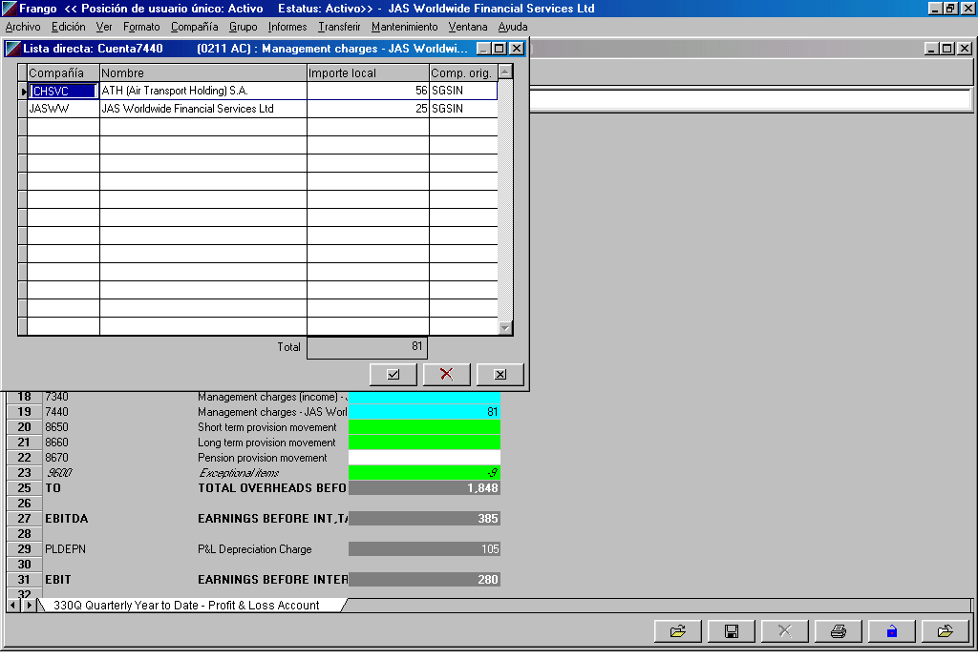

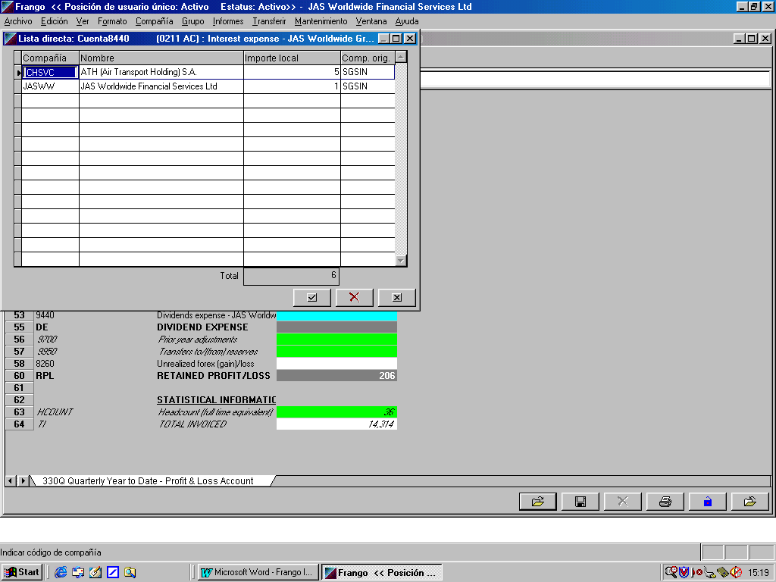
Form 330Q Profit and Loss Account – detail of account 8440

Form 340Q Reserve Movements
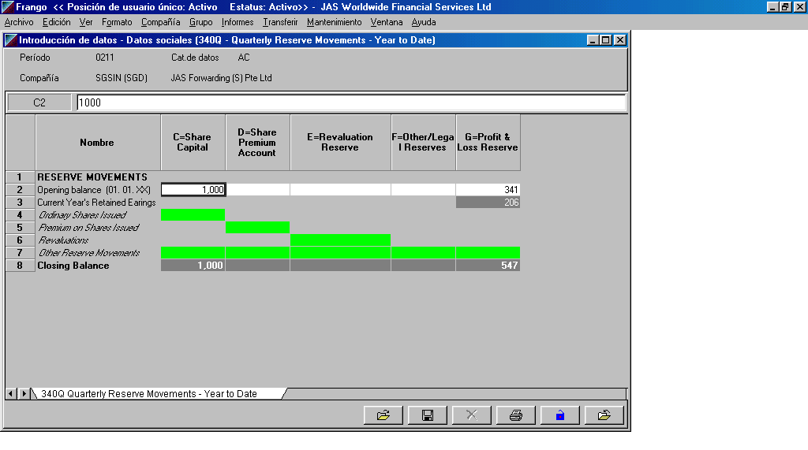

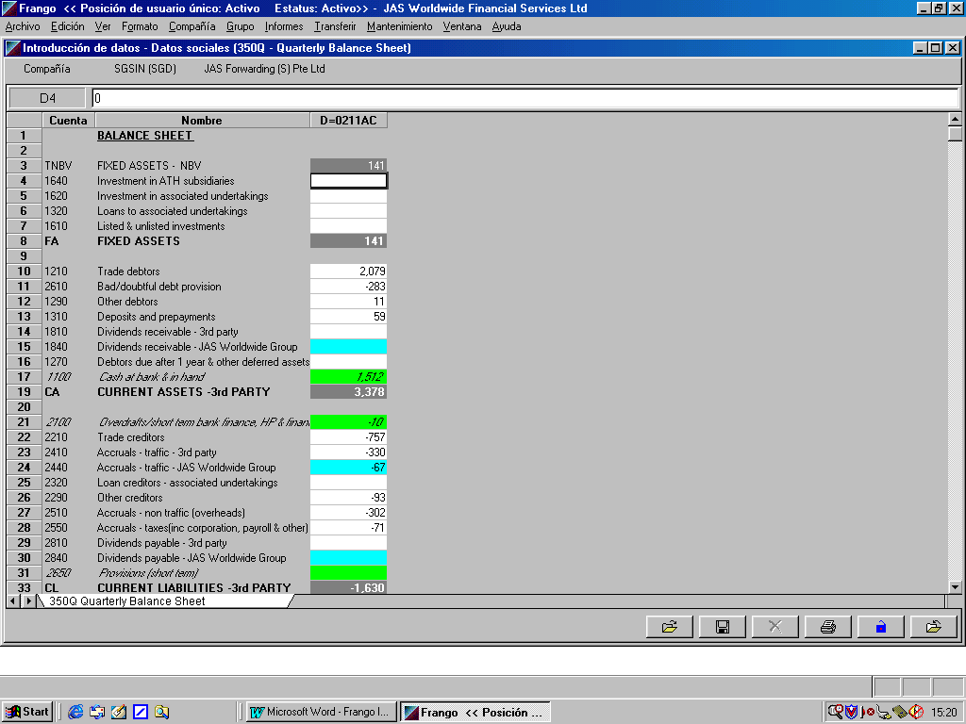
Form 350Q Balance Sheet

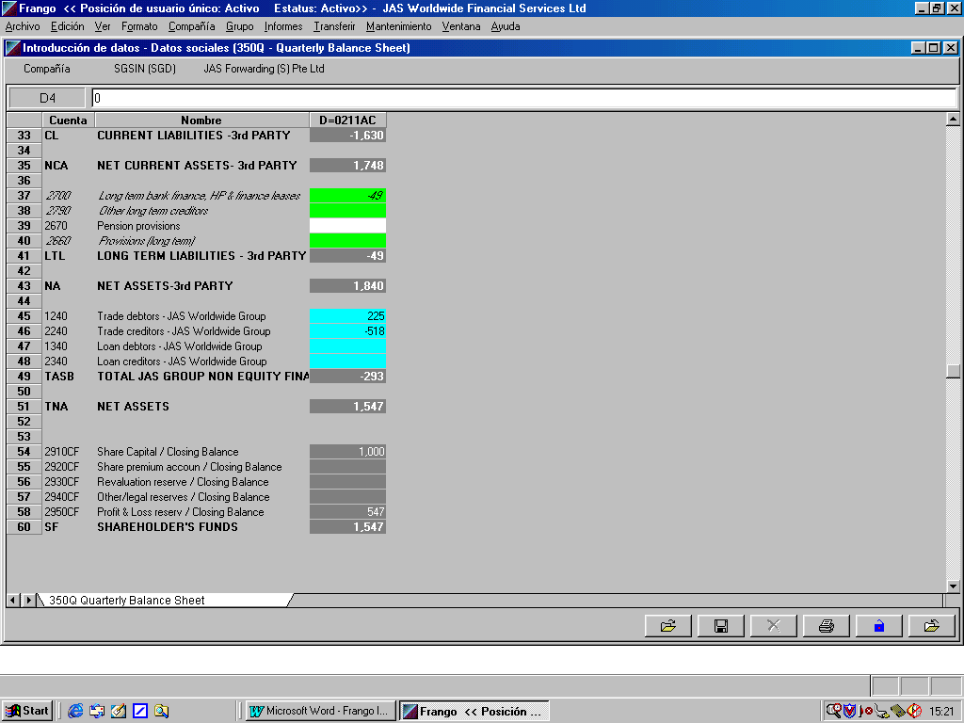
Form 350Q Balance Sheet (ctd)
Form 350Q Balance Sheet – detail of account 2440

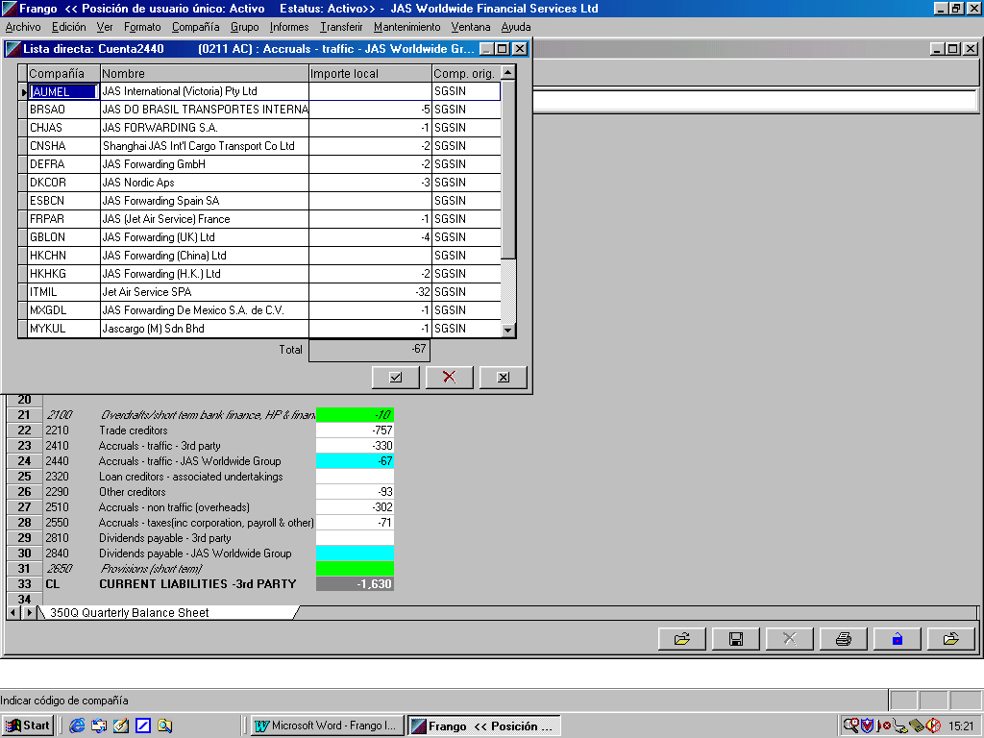

Form 350Q Balance Sheet – detail of account 2440 (ctd)
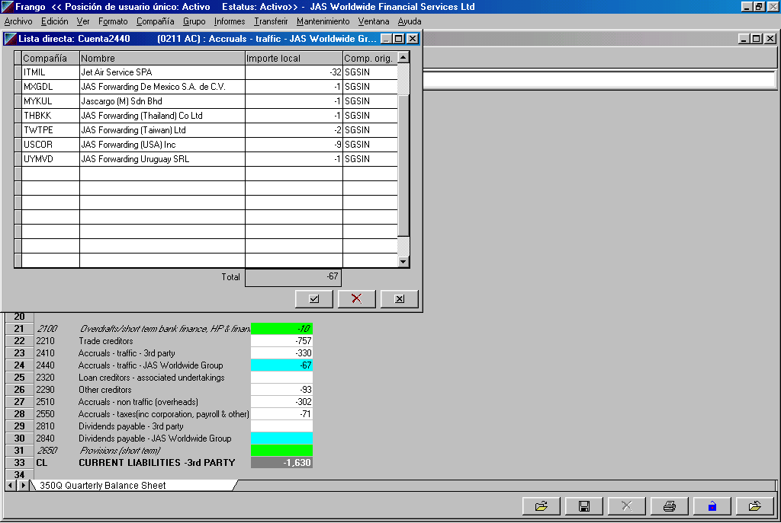

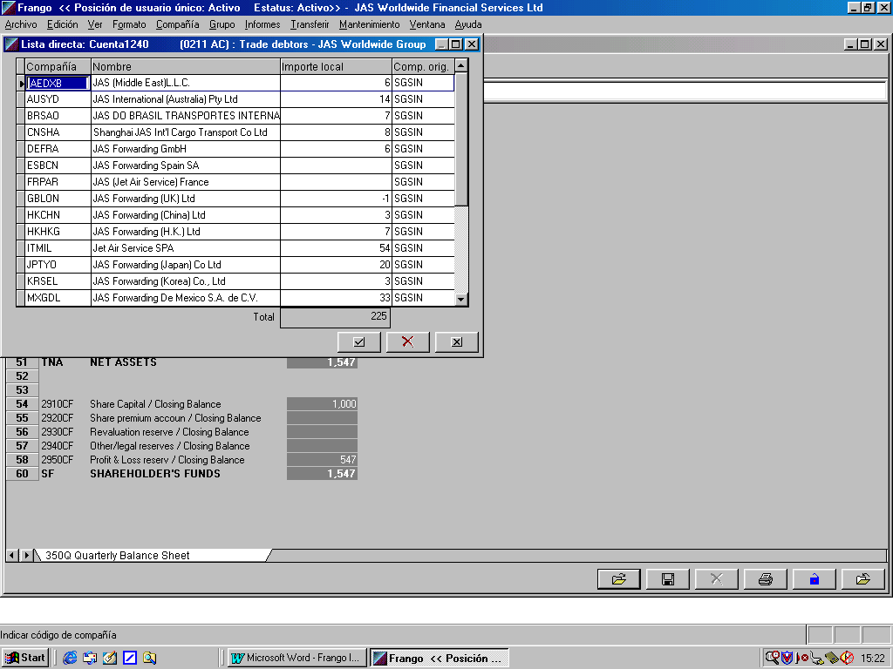
Form 350Q Balance Sheet – detail of account 1240

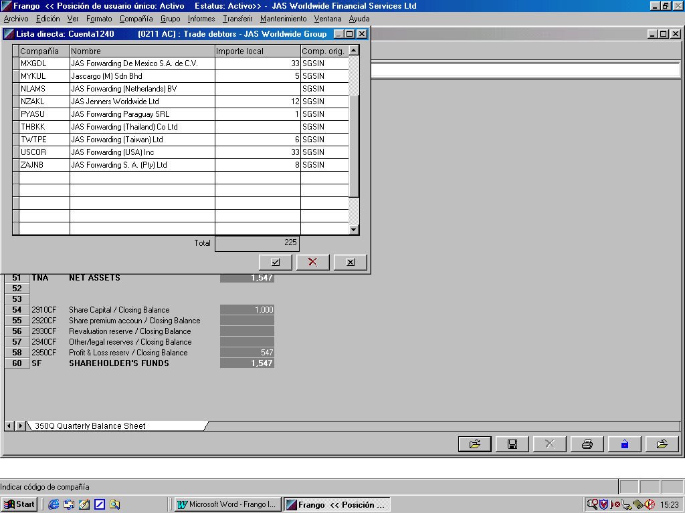
Form 350Q Balance Sheet – detail of account 1240 (ctd)

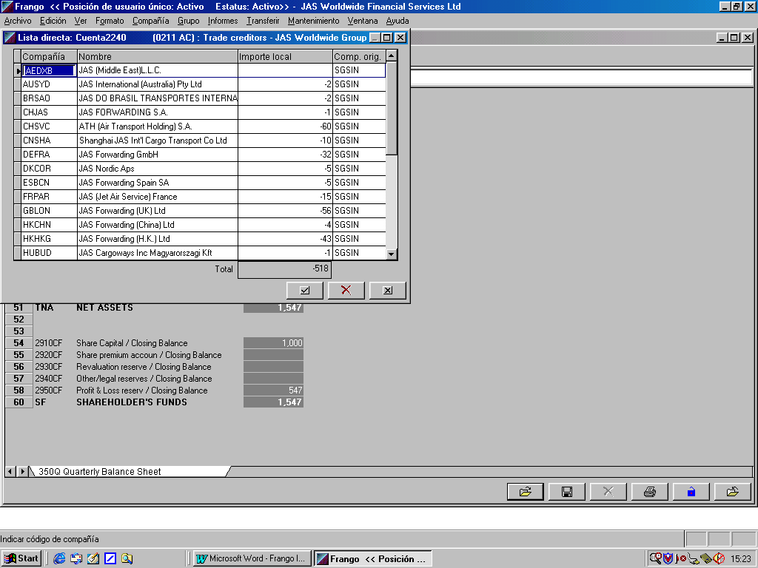

Form 350Q Balance Sheet – detail of account 2240

Form 350Q Balance Sheet – detail of account 2240 (ctd)
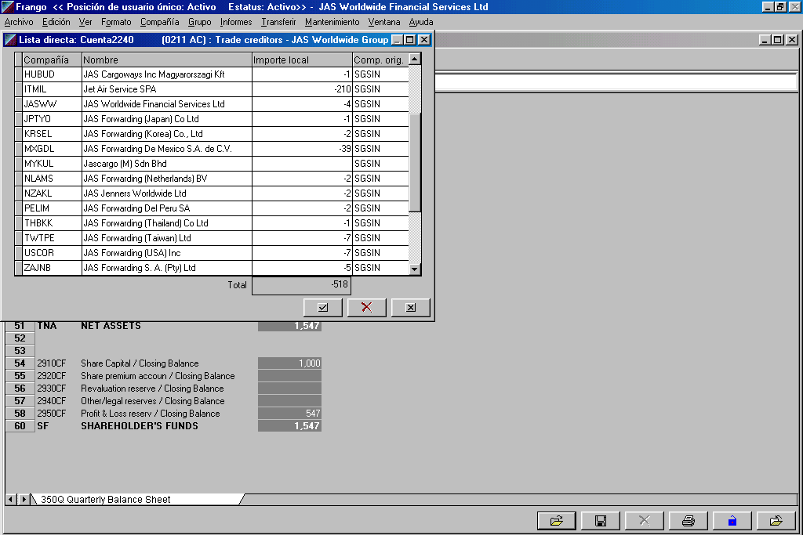

Loan Debtors JAS Worldwide Group - detail of account 1340

In sample csv file no amounts are shown under this account code. To illustrate a loan balance due of 2100000.99 from DEFRA this would be included in csv file as follows:
Loan debtors - JAS Worldwide Group,1340,DEFRA,,,, 00002100000.99+

As this is not a trade debtor the amount is likely to be recorded in a nominal ledger account code

Loan Creditors JAS Worldwide Group - detail of account 2340

In sample csv file no amounts are shown under this account code. To illustrate a loan balance of 1000026.81 with CHSVC this would be included in csv file as follows:
Loan creditors - JAS Worldwide Group,2340,CHSVC,,,, 00001000026.81-

As this is not a trade creditor the amount is likely to be recorded in a nominal ledger account code.

Section 9: Other documents for reference

0211SGSINac.csv
The sample csv file for period 0211 (ie year to date figures to November 2002 for sample company SGSIN)

0211SGSINac with notes.xls
This provides an annotated line by line detailing where figures provided in csv are shown in input forms in Frango, had they been entered manually.

Frango Excel sheets with CSV sheetV0.10 .xls
This shows Frango codes and signage for accounts which are included in Frango input forms as at 20.01.03

Section 10: Frango developments to be borne in mind

Modifications to enable output for csv file should take into account the following

Branches
The Frango report submission in future will include a requirement to provide information at a branch level

New codes
Usually a number of new account codes are created within Frango Chart of Accounts during the course of an year. Any necessary configuration in local accounting and or traffic systems should be flexible to allow new codes to be created without the necessity to make modifications to extraction program used to generate the csv file.

Cashflow reporting
This will be introduced during 2003 and will involved providing related detail analysis for certain accounts and creation of new accounts

Period 13
This additional period is where final results are provided at year end. Period 12 will be used to collect draft figures. A csv file must be created for period 13.

Audit Pack
For year ended 2002, each office will be required to provide additional information such as supporting notes to the final accounts in excel, which will be subsequently imported into Frango. At a future stage this information may be provided through a file extracted/created from information held in local systems.

Glossary

Term | Description
FRANGO | The Group Reporting and Consolidation Package
Account Code | The Frango Code in Frango chart of accounts
Counter Company | The corresponding company for inter company transactions for JAS Worldwide Group Companies
Mode | The type of business
Amount | The full amount in local reporting currency as defined with Frango reporting Structure Eg: ARBUE ARP, UYFSA USD

